


Multi-Functional Cane

ELBC803- Embedded Design Project
By

Ali Yazbeck –
Serena Haidar – 90457
Zein Attar - 94266

Submitted to the Faculty of Engineering of the
Islamic University in Lebanon
Baalbeck, Lebanon
in partial fulfillment of the requirements for the degree of

BACHELOR OF ENGINEERING IN COMPUTER AND COMMUNICATIONS
Spring 2024-2025

Approved by:
Dr. Mohammad Chreif

TABLE OF CONTENTS

CHAPTER 1 INTRODUCTION 1
CHAPTER 2 System Design and Implementation 3
2.1 Introduction 3
2.2 Required Components 3
2.3 Circuit Design 4
2.4 Implementation Steps 5
CHAPTER 3 Conclusion and Future Work 8
3.1 Conclusion 8
3.2 Future Work 8

LIST OF FIGURES

Figure ‎2-1 Complete circuit 5
Figure ‎2-2 Circuit 5
Figure ‎2-3 Led connections 6
Figure ‎2-4 Connecting Arduino to breadboard 6

INTRODUCTION

In this chapter you are required to introduce the idea of your project (in one page or two). Your introduction should cover the following elements:
- What is Engineering and what are the fields covered by engineering.
- The idea of your project, what is the objective it serves for and what are the problems solved by such a project.
- What is Arduino, what it is used for.

General notes to respect:
- This is a template. That means you should respect the format, the font size and type, the chapter titles and change only the content of each chapter and paragraph according to your project.
- Each chapter should start in a new page
- You cannot copy/paste from the internet without linking the statements with your own way (this will be called plagiarism and it is not accepted in academic reports).
- The list of content and the list of figures are dynamic so you should not write in them. Instead, right click on them and click Update Field.
- Figures should be numbered based on the chapter numbering (e.g. Figure 2.3 is the third figure in chapter 2).
- Figures should have captions under them to explain what is this figure and this caption is the one that will be used in the list of figures.
- Figures should be cited inside your text (e.g. in Figure2.3 we can see…. Figure 2.3 illustrates the …. as shown in Figure2.3, etc.).

System Design and Implementation

Introduction
In this chapter, you need to list the components you will use in your project and the steps you will follow to implement it with figures to illustrate your text.

Required Components
In this paragraph you need to list the components of your project. Only those that you used:

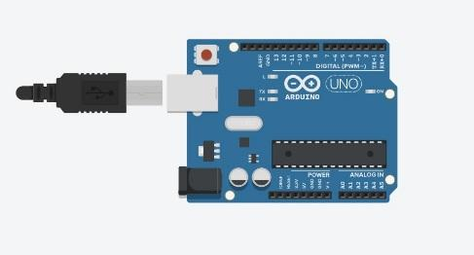 | ARDUINO UNO R3 x1  The main brain for the system.
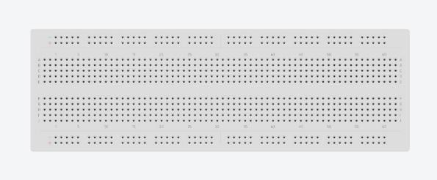 | Breadboard x1  For the connection and components
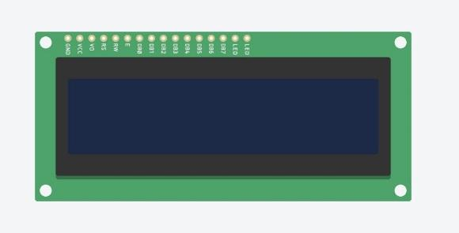 | 16*2 LCD x1  To display the temperature
 | RGB LED x7  To indicate the color corresponding to each temperature
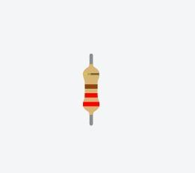 | Resistor 220-ohm x7  To implement electrical resistance as a circuit element
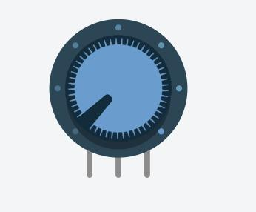 | Potentiometer x1  To measure electric potential
 | Temperature sensor x1  To measure the amount of heat energy or even coldness that is generated by an object or system
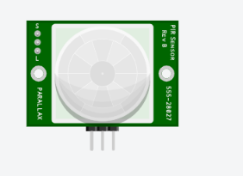 | PIR sensor X1

Circuit Design

In Figure ‎2-1, we show …
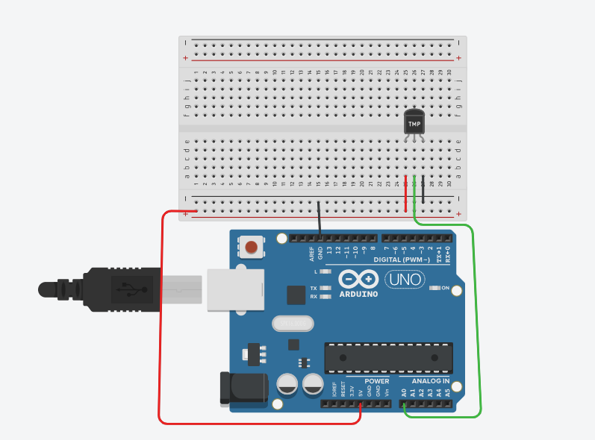
Figure ‎2-1 Circuit

Implementation Steps
Here, you need to explain how did you implemented your project with figures explaining the different steps.
- Step 1
We connect the led to the pin … as shown in
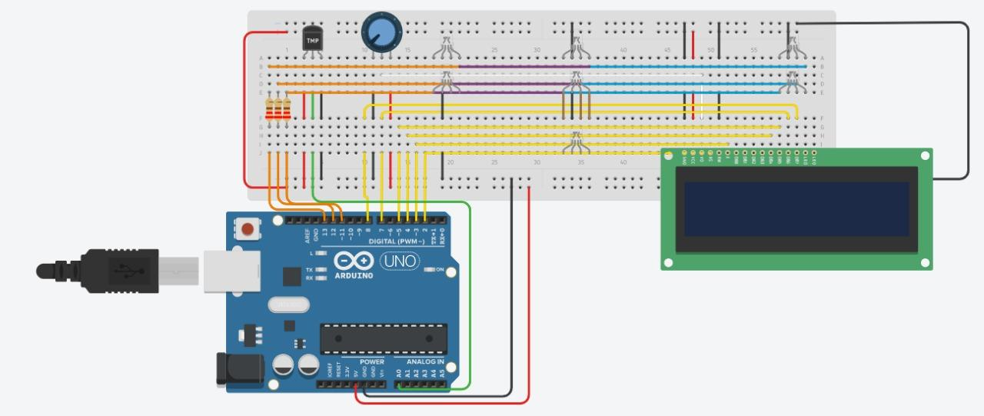
Figure ‎2-2 Led connections

An example of a figure is shown in Figure 2.2. Pay attention how this figure has a caption under it. This is done by right clicking on your figure and then choosing “insert a caption”.

The list of figures in page III is dynamic. You need to right click on it and update it when you finish inserting all your figures and captions so it is updated with the final figures in your report.
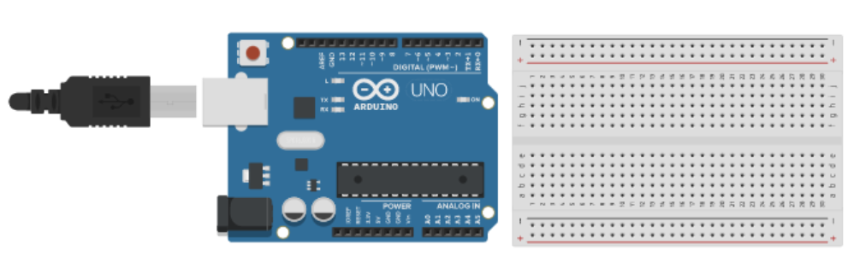
Figure ‎2-3 Connecting Arduino to breadboard

Conclusion and Future Work

Conclusion
In this paragraph, you write a summary of what you presented in the above two chapters. Instead of using expressions like “in our project we will implement ….”, in the conclusion we usually use expressions like “As we could see above, in our project we implemented ……”.
Besides, you need to write about the experiences you learned while taking the course and implementing the project.

Future Work
In this paragraph, you need to write any idea you have about expanding the work you did in your project to be more developed and to be used in real life.

